Day 34: 28-11-2025:

Spring with JWT with Mongo Db
Starter Web
Starter Mongo DB / MySQL and JPA
Starter validation (for validation purpose)
Starter security
Starter testing
Starter Lombok (it help to avoid writing boiler code for java bean as setter, getter, toString, constructor etc). @Data, @Setter, @Getter,@ToString
jjwt-apijjwt-impljjwt-jackson

while creating typescript or JavaScript project we need to add few configuration file
In JavaScript as well as TypeScript we need to create package.json file. This file hold the configuration details about your project.

npm init : it is use to create JavaScript as well as TypeScript configuration details. package.json file

Or

npm init -y : file create with default configuration details.

Typescript configuration file tsconfig.json file
tsc --init

TypeScript with Oops concept

- Class style object creation we can use private or public keyword inside constructor to make variable as instance variable.
- Class style object support inheritance like java it provided extends as well as implements keywords.
- It provide interfaces concept.
  - Interface contains only property : to create type of object with literal style
  - Interface contains only behaviour : to provide the specification.

Type script modules like a package in java.

Module is a collection of function, variable, classes and interface part of different files. Using the module concept we can break the code in different files base upon file functionality.

Using import or require (node js) and export we can link both the file.

Create folder
Sample-typescript-app
npm init -y package.json (which contains project configuration).
tsc --init tsconfig.json

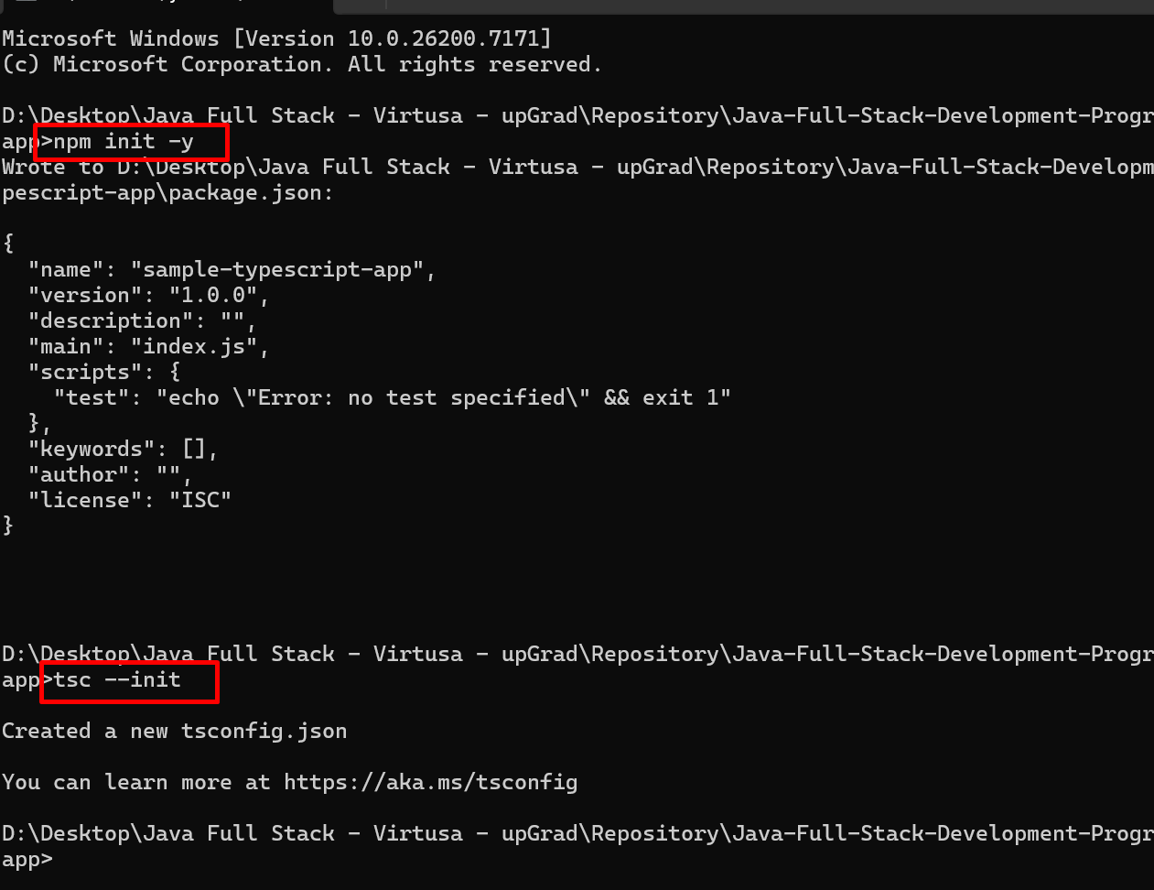

src - ts
target ts
index.html
styles.css

